|  |  |
| --- | --- |
| Date | 25 October 2022 |
| Team ID | PNT2022TMID45267 |
| Project Name | Global Sales Data Analytics |

**Project Development Delivery of Sprint -4**

**Task 1: Merge 12 months of sales data into a single CSV file**

**Task 2: Create new ‘Month’ column from ‘Order Date’ column**

**Task 3: Add a Sales column**

**Task 4: Add a City column**

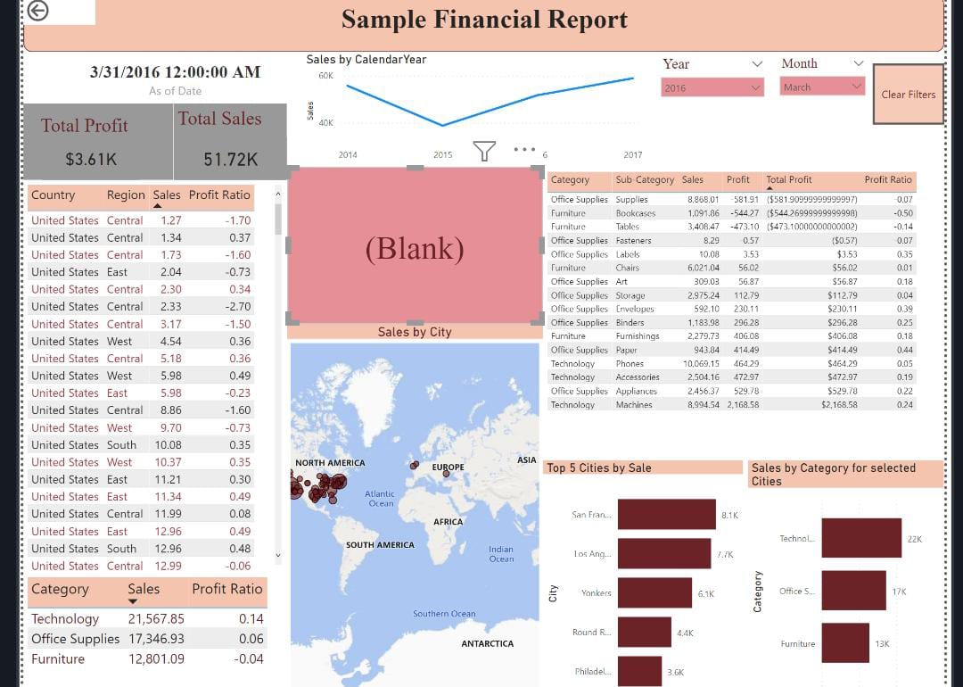

**Analysis of the sales data with Particular focus given to how promotions And advertising translate into sales, in terms of both units sold and sales Dollars.**

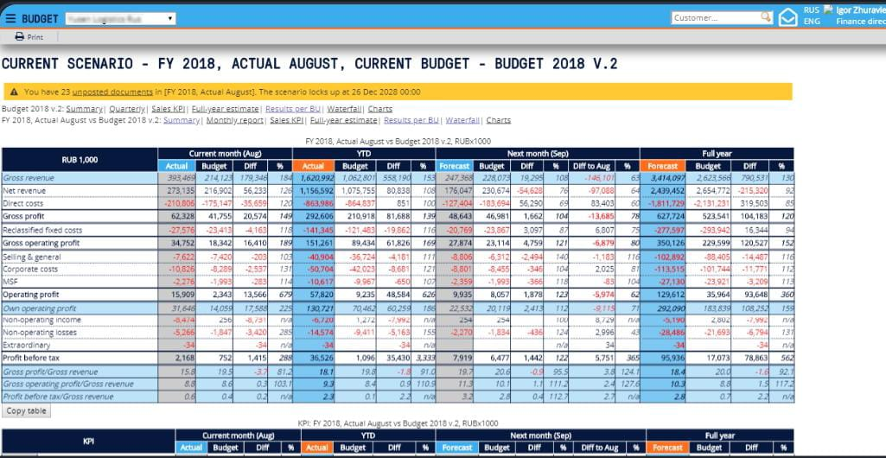

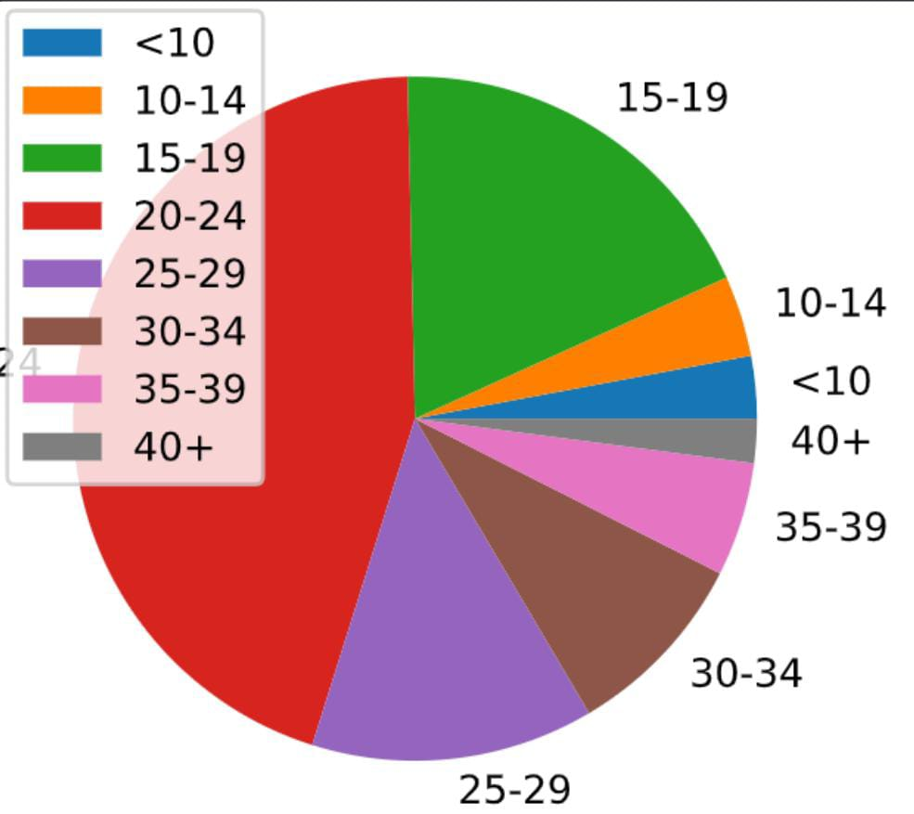

**Import**

**Numpy as np**

**Import pandas as pd**

**Import matplotlib.pyplot as plt**

**Autplotlib inline**

**sales = pd.read_csv(**

**data/sales_data.csv" parse dates pate**

**FiletatFoundError**

**Traceback (most recent call last)**

**sipython-net-25-112222 in odule>()**

**sales pd.read_csv( data/sales data.co**

**parse dates 'Date'])**

**sales.head()**

**NameError**

**Traceback**

**(most recent call last)**

**Cixibon Input-25-46aft**

**In dele()**

**I sales.head()**

**NameError:**

**Name ‘sales” is not defined**

**SEARCH STACK OVERFLOW**

**Sales Customer Age 1.mean()**

**Traceback (most recent call last)**

**Sales[‘cstomer Age]mean()**

**Error: name ‘sales is not defined**

**SEARCH STACK OVERFLOW**